# Practical exercises for Git and GitHub

**(Remember that you will be provided with a student account)**

## Exercise 1: Setting Up Git and GitHub

**Task:** Install Git on your computer and configure your username and email.

**Task:** Create a GitHub account if you don't have one.

## Exercise 2: Initialising a Repository

**Task:** Create a new directory for your project.

**Task:** Initialise a new Git repository in the directory.

**Task:** Create a README.md file and write a brief description of your project. If the file README.md does not exist in the directory where you are running the command, you will get an error. Make sure the file exists in the directory. You can create it if it doesn't exist using the ***echo*** command or any other.

**Task:** Add and commit the README.md file to the repository.

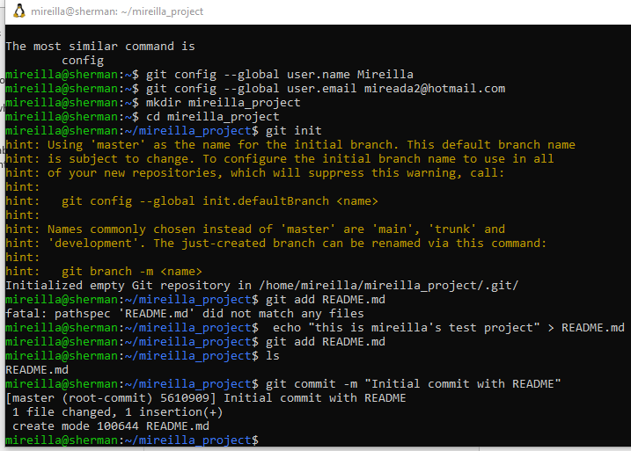

## Exercise 3: Connecting to GitHub

**Task:** Create a new repository on GitHub without initialising it with any files.

**Task:** Link your local repository to the GitHub repository.

*git remote add origin https://github.com/Mireilla/mireilla_project.git*

**Task:** Push your initial commit to GitHub.

*git push -u origin main*

## Exercise 4: Branching and Merging

**Task:** Create a new branch called feature and switch to it.

*git branch feature*

*git checkout feature*

**Task:** Make some changes to your project (e.g., add a new file), then add and commit the changes.

*git add mireilla_file.txt*

*git commit -m "Added new file in feature branch"*

**Task:** Switch back to the main branch and merge the feature branch into main.

*git checkout main*

*git merge feature*

## Exercise 5: Collaborating on GitHub

**Task:** Fork an existing repository on GitHub.

**Task:** Clone the forked repository to your local machine.

*git clone https://github.com/yourusername/SomeProject.git*

**Task:** Make some changes and push them to your fork.

**Task:** Create a Pull Request to the original repository.